Tutorial: Introduction to Storm

# Overview

**Welcome**

Welcome to the Storm tutorial. This tutorial covers the critical skills needed to develop a Storm application. It starts with an already deployed Storm environment where students will execute a series of hands-on labs.

**Objectives**

Upon completing this tutorial, students will be able to:

* Set up an all-in-one Storm installation
* Develop a simple Storm application (Word Count)
* Compile Storm applications
* Run Storm applications and examine the output

**Structure**

This guide is designed as step-by-step instructions for hands-on exercises. It teaches you, in the examples that follow, how to operate Storm service in a functional test environment. While working through this tutorial, you will:

1. Download and Setup an all-in-one Storm VM through a process similar to the one you followed in the MapReduce tutorial
2. Develop a simple “**Word Count**” application and build it
3. Run the application on Storm and examine the output

# Requirements

This section is similar to week 2 Tutorial 1, which focused on MapReduce. If you have already successfully completed that tutorial, you can skip to Step 10.

To run the all-in-one virtual machine you need to have a hypervisor such as **Virtual Box** installed. You can grab a copy of **Virtual Box** for free from the following URL:

|  |  |
| --- | --- |
|  | **https://www.virtualbox.org/wiki/Downloads** |

For command line steps, you need a SSH client:

* If using Linux and OS X, you should already have it installed.
* If using Windows, you can download a free copy of the **Putty** from the following URL:

|  |  |
| --- | --- |
|  | http://www.chiark.greenend.org.uk/~sgtatham/putty/download.html |

# Set Up Storm Virtual Machine

Before diving into Storm, we need to set up the environment. This tutorial uses an all-in-one Storm virtual machine made by Hortonworks. Later this virtual machine is also used for Programming Assignments.

**Step 1:** Download the Hortonworks Sandbox:

Download the **Virtual Machine for VirtualBox** from the following link:

|  |  |
| --- | --- |
|  | http://hortonworks.com/products/hortonworks-sandbox/#install |

You may want to download the latest version. This tutorial uses “HDP 2.3 Preview on Hortonworks Sandbox”.

|  |  |
| --- | --- |
|  | For more information about this virtual machine and details about the installation process, please refer to the Install Guide at:  http://hortonworks.com/products/hortonworks-sandbox/#install |

**Step 2:** Open **VirtualBox**; then select **File > Import Appliance …**.

**Step 3:** Follow the instructions to import the downloaded file. Make sure the VM uses the following settings:

|  |  |
| --- | --- |
| **Ram** | 2048 MB |
| **CPU** | 2 |

**Step 4:** Start the virtual machine. After a few moments, you should be able to see the login screen on the virtual machine.

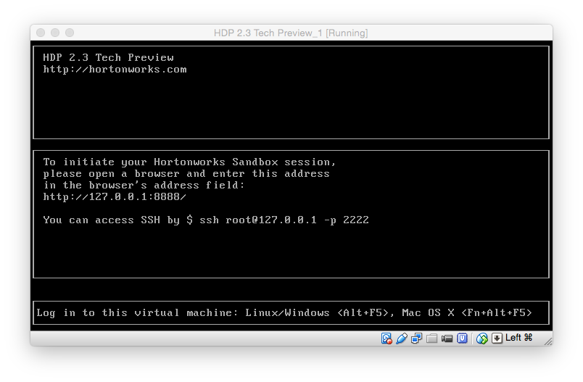

**Step 5 (OS X, Linux):** Open the terminal on your machine (*not* on the virtual machine), and log in to the virtual machine via SSH protocol. The password is **hadoop**. (Ignore the leading # in the commands. It is just an indicator that the command has to run in a terminal.)

|  |
| --- |
| # ssh root@127.0.0.1 -p 2222 |

**Step 5 (Windows):** Open **Putty** on your machine, and log in to the virtual machine via SSH protocol using following information:

|  |  |
| --- | --- |
| **Server** | 127.0.0.1 |
| **Port** | 2222 |
| **Username** | root |
| **Password** | hadoop |

**Step 6:** After successfully log in, you should see a prompt similar to the following:

|  |
| --- |
| [root@sandbox ~]# |

**Step 7:** Before continuing, you need to install the **nano** text editor. Run the following command, and then complete the installation instructions:

|  |
| --- |
| # yum install nano |

**Step 8:** After the installation is done, check the installation using the following command:

|  |
| --- |
| # nano |

**Step 9:** Quit **nano**.

**Step 10:** In order to build and package Storm applications, we need **maven**. In order to install maven, run the following commands:

|  |
| --- |
| # wget [http://repos.fedorapeople.org/repos/dchen/apache-maven/epel-apache-maven.repo -O /etc/yum.repos.d/epel-apache-maven.repo](http://repos.fedorapeople.org/repos/dchen/apache-maven/epel-apache-maven.repo%20-O%20/etc/yum.repos.d/epel-apache-maven.repo)  # yum install apache-maven |

**Step 11:** Change the current folder:

|  |
| --- |
| # cd storm-tutorial |

# Hello World (Word Count)

The **Word Count** application is the canonical example in Strom. In this tutorial, we are going to build all the components needed step-by-step and then build the whole application. In order to have a Word Count application, you need to create a Storm Topology as below:

As is seen above, this topology has three main components:

* **Spout**: In this topology, the Spout is emitting sentences as an output. In this tutorial, we are going to build a Spout that randomly emits a sentence from a predefined set in the Spout.
* **Split Bolt**: This bolt inputs a tuple in the form of a sentence and then emits a tuple for each word in the sentence.
* **Count Bolt**: This bolt keeps track of the count of each word. It does so by inputting tuples in form of words and incrementing the count for each word accordingly. Additionally, it emits the new count for each word. For example, if the tuple being read is the word “apple” and the current count for “apple” is 5 in the bolt, it will increment the internal count to 6 and emit a tuple in form of (“apple”, 6).

Counts

Words

Sentence

In the remaining of the tutorial, we are going to explain how to build each of the components mentioned above and how to wire them up to create the whole topology.

|  |  |
| --- | --- |
|  | If you are new to Java programming language, take a look at:  https://docs.oracle.com/javase/tutorial/ |

**Step 1:** Make sure you are in the “storm-tutorial” directory. You can go to that directory by using the following command:

|  |
| --- |
| # cd ~/storm-tutorial/ |

|  |  |
| --- | --- |
|  | This example is adapted from the storm-starter package in Storm’s source code. To learn more about developing Storm applications in Java, visit:  https://github.com/apache/storm/tree/master/examples/storm-starter  https://storm.apache.org/documentation/Tutorial.html |

## Spout

**RandomSentenceSpout.java** randomly chooses one of the sentences in “String[] sentences”, and emits it as a tuple.

## Split Bolt

**SplitSentenceBolt.java** reads a sentence and splits it into words, then it emits a tuple for each word.

## Count Bolt

**WordCountBolt.java** keeps an in-memory hash map of words to their count value. Upon receipt of a tuple it increments the count for that word and emits the new count as a tuple in the format of (“word”, count).

## Word Count Topology

Now that we have all the components, we have to build the Storm Topology.

**WordCountTpology.java** creates a “ToplogyBuilder” instance which wires up all the components and submits the topology. It first adds the 5 instance of the spout. Then it connects 8 instances of the SplitBolt to the spout, and 12 instances of the CountBolt to the SplitBolt.

After building the topology, it submits the topology, runs the topology for 10 seconds, and then stops the application.

## Building and Submitting the Job

**Step 2:** Compile the source code using the following command, which will create a folder called “target” and build a fat jar under that folder:

|  |
| --- |
| # mvn clean package |

**Step 3:** Go to the target folder using the following command:

|  |
| --- |
| # cd target |

**Step 4:** Run the application using the following command:

|  |
| --- |
| # storm jar storm-example-0.0.1-SNAPSHOT.jar WordCountTopology |

You should see an output similar to the one below:

|  |
| --- |
| # [Thread-28-spout] INFO backtype.storm.daemon.task - Emitting: spout default [the cow jumped over the moon]  12608 [Thread-26-split] INFO backtype.storm.daemon.executor - Processing received message source: spout:8, stream: default, id: {}, [the cow jumped over the moon]  12608 [Thread-26-split] INFO backtype.storm.daemon.task - Emitting: split default [the]  12608 [Thread-26-split] INFO backtype.storm.daemon.task - Emitting: split default [cow]  12608 [Thread-26-split] INFO backtype.storm.daemon.task - Emitting: split default [jumped]  12608 [Thread-26-split] INFO backtype.storm.daemon.task - Emitting: split default [over]  12608 [Thread-26-split] INFO backtype.storm.daemon.task - Emitting: split default [the]  12609 [Thread-26-split] INFO backtype.storm.daemon.task - Emitting: split default [moon]  12611 [Thread-16-count] INFO backtype.storm.daemon.executor - Processing received message source: split:7, stream: default, id: {}, [cow]  12611 [Thread-16-count] INFO backtype.storm.daemon.task - Emitting: count default [cow, 55]  12611 [Thread-16-count] INFO backtype.storm.daemon.executor - Processing received message source: split:7, stream: default, id: {}, [jumped]  12611 [Thread-16-count] INFO backtype.storm.daemon.task - Emitting: count default [jumped, 55]  12611 [Thread-18-count] INFO backtype.storm.daemon.executor - Processing received message source: split:7, stream: default, id: {}, [the]  12611 [Thread-18-count] INFO backtype.storm.daemon.task - Emitting: count default [the, 213]  12611 [Thread-18-count] INFO backtype.storm.daemon.executor - Processing received message source: split:7, stream: default, id: {}, [over]  12611 [Thread-18-count] INFO backtype.storm.daemon.task - Emitting: count default [over, 55]  12611 [Thread-18-count] INFO backtype.storm.daemon.executor - Processing received message source: split:7, stream: default, id: {}, [the]  12611 [Thread-18-count] INFO backtype.storm.daemon.task - Emitting: count default [the, 214]  12611 [Thread-18-count] INFO backtype.storm.daemon.executor - Processing received message source: split:7, stream: default, id: {}, [moon] |